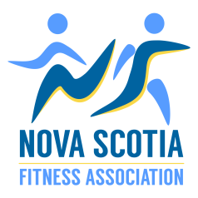
Community Impact Award Application
*Please note you must be an active NSFA Member to apply*
Name:________________________ Phone Number:_______________________
Email Address:_________________________________
Street Address: ________________________________________________________________________

In 500 words or less describe the impact you have made on your community through volunteer fitness leadership:

Please attach two letters of support from persons knowledgeable about your volunteer fitness work.

Please send all applications to events@nsfitness.ca by March 15, 2017 to be considered. Thank you to all the applicants. A winner will be chosen by the NSFA Board and presented the award at the Summit on April 22.

